Docs Left Astray
Documentation Decay in Software Engineering
A Systematic Literature Review
Bernard Barnieh and Alexander Wolf
COIS-5210H Advanced Topics in Software Engineering
Trent University, Fall 2026
Instructor: Dr. Taher Ghaleb
November 2026
Table of Contents
1 Introduction 1
2 Background and Related Secondary Studies 2
2.1 Background 2
2.2 Related secondary studies 2
3 Research Methodology 4
3.1 Research questions 4
3.2 Search strategy 5
3.3 Inclusion and exclusion criteria 6
3.4 Study selection 6
3.5 Data extraction 8
3.6 Analysis and synthesis 9
4 Results 10
4.1 RQ1: How has research on documentation decay evolved? 10
4.2 RQ2: Which datasets and data sources are used? 12
4.3 RQ3: Which techniques are used? 14
4.4 RQ4: How are the approaches evaluated? 15
4.5 RQ5: What are the main findings across the studies? 18
4.6 RQ6: Which limitations and open problems remain? 19
5 Discussion 20
5.1 Research trends and maturity 20
5.2 Methods and datasets 20
5.3 Evaluation 20
5.4 Strength of evidence and inconsistencies 21
5.5 Implications for researchers and practitioners 21
6 Research Gaps and Future Directions 21
6.1 What has been well studied 21
6.2 What has received limited attention 22
6.3 Limitations future work should address 22
6.4 Open research questions 22
6.5 Connection to the proposed project 22
7 Threats to Validity 23
8 Conclusion 23
9 Disclosure of Generative AI Use 24
References 25
List of Tables iii
List of Figures iii
List of Tables
Table 1: Secondary Studies Related to Documentation Decay 2
Table 2: Research Questions 4
Table 3: Records Retrieved by Source 5
Table 4: Inclusion and Exclusion Criteria 6
Table 5: Quality Assessment Questions 7
Table 6: Data Extraction Form 9
Table 7: Topic Clusters in the Term Co-occurrence Map 12
Table 8: Data Sources and Scale of the Primary Studies 13
Table 9: Commonly Used Benchmark Datasets 13
Table 10: Task by Approach Family 14
Table 11: Reported Performance on Shared Benchmarks 17
Table 12: Reported Limitations and Future Directions 19

List of Figures
Figure 1: PRISMA 2020 Flow Diagram of the Study Selection 8
Figure 2: Primary Studies per Publication Year, by Documentation Artifact 10
Figure 3: Term Co-occurrence Map of the Titles and Abstracts of the 74 Studies 11
Figure 4: Approach Families by Publication Period 15
Figure 5: Evaluation Measures Reported by the Primary Studies 16

1 Introduction
Developers rely on documentation to understand, use, and maintain software, and they report that inaccurate documentation is one of its most frustrating problems [1], [4]. Documentation is written once, but must remain true while the software keeps changing. Parnas described this gradual loss of fit as software aging [2], and early studies showed that code and comments frequently fail to evolve together [3]. When a function is renamed, an API is deprecated, or an installation step changes, comments, API references, and README files that are not updated begin to describe a system that no longer exists. This review calls this phenomenon documentation decay.
Decayed documentation has practical costs. Outdated comments mislead maintainers and can hide defects [5], outdated API documentation leads clients to use APIs incorrectly [6, 7], and outdated README instructions prevent users from installing or running software [8, 9]. Over the last decade, researchers have proposed detectors, updaters, and empirical studies for different kinds of documentation, and since 2024, large language models have opened new possibilities. However, this work is scattered across artifacts, tasks, and venues, and the existing secondary studies either predate most of it or cover only part of it (Section 2). This review, therefore, analyses 74 primary studies published between 2016 and 2026 to answer six research questions:
- RQ1 (Evolution). How has research on documentation decay evolved?
- RQ2 (Datasets and data sources). Which datasets and data sources are used?
- RQ3 (Techniques). Which techniques are used?
- RQ4 (Evaluation). How are approaches evaluated?
- RQ5 (Outcomes). What are the main findings?
- RQ6 (Limitations and gaps). Which limitations and open problems remain?
The contributions of this review are a systematic map of the field, a classification of techniques, data sources, and evaluation practice, a synthesis of what the studies have found, a set of research gaps, and a verified data extraction sheet. The extraction sheet, search strings, and analysis files are available in a replication package on GitHub (https://github.com/Invincible1811/docs-left-astray-slr). Section 1 is the introduction to this study. Section 2 presents background and related secondary studies, Section 3 the method, Section 4 the results, Section 5 the discussion, Section 6 the research gaps and future directions, Section 7 threats to validity, Section 8 the conclusion, and Section 9 the disclosure of generative AI use.

2 Background and Related Secondary Studies

2.1 Background
Documentation decay is the process by which documentation becomes inaccurate, incomplete, or misleading because changes to the code, its dependencies, or its environment are not reflected in it. The literature uses several related terms. Drift describes the cause, code, and documentation moving apart; staleness or obsolescence describes the observable state of a document that no longer matches; and code–comment inconsistency is a broader term that also covers documentation that was wrong from the start. Decay affects code comments and docstrings, API reference documentation, README and repository documentation, tutorials, design models, and legal texts such as end-user licence agreements. Detection approaches work either post hoc, checking a snapshot of code and documentation, or just in time, checking a code change before it is committed [10].

2.2 Related secondary studies
A search for secondary studies identified five reviews related to this topic (Table 1). None of them focuses on documentation decay across artifacts.
Table 1: Secondary Studies Related to Documentation Decay
Study | Type | Topic | Period | Studies
Zhi et al. (2015) | Systematic mapping | Cost, benefits and quality of software documentation | 1971–2011 | 69
Rani et al. (2023) | SLR | Code comment quality assessment | 2011–2020 | 47
Pinho et al. (2024) | Systematic mapping | Challenges and solutions of FOSS documentation | 2013–2023 | 12
Mohamed et al. (2025) | Narrative review | Detecting and managing documentation drift | Not stated | 12 references
de Almeida et al. (2026) | Systematic mapping | Problems related to API documentation | 2016–2025 | 61
This review | SLR | Documentation decay across artifacts | 2016–2026 | 74
Source: Researchers’ construction (2026) from the cited reviews.

Zhi et al. [11] mapped 69 papers published between 1971 and 2011 on the cost, benefits, and quality of software documentation. Fifty papers addressed quality, 37 benefit, and 12 cost, and the most studied quality attributes were completeness, consistency, and accessibility. The authors judged the field immature and called for more validation and industrial studies. Because the review ends in 2011, it predates almost all automated work on decay, and it treats up-to-dateness only as one quality attribute among many.
Rani et al. [12] reviewed research on assessing code comment quality from 2011 to 2020. They selected venues from the CORE ranking, searched 20 conferences and six journals through DBLP, screened 2,043 candidate papers, and added studies through snowballing, for 47 studies in total. They found 21 quality attributes, with a clear predominance of consistency between comments and code, and noted that most studies focus on Java and rely on manual assessment. Their limitations include possibly missed studies, an initial screening agreement of only 0.36, and the exclusion of industry tracks. The present review differs by covering artifacts beyond comments, by focusing on decay caused by change, and by including the period after 2020, in which 54 of the 74 included studies were published.
Pinho et al. [13] mapped challenges and solutions of documentation in free and open-source software published between 2013 and 2023. From 1,271 papers, they included 12 and identified five challenges, including maintainability and incompleteness, and three kinds of solutions: strategic use of README files, artificial intelligence, and support tools. Its small final set and FOSS focus limits its depth on decay, but it supports this review’s finding that README documentation is understudied.
Mohamed et al. [14] surveyed solutions for documentation drift, from synchronisation algorithms and traceability recovery to machine learning and LLM-based tools. It is a short narrative review that cites 12 works and reports no search strategy, selection criteria or quality assessment, so it cannot show how representative its picture is. It was found by the search of this review and excluded as a secondary study.
De Almeida et al. [15] mapped problems related to API documentation reported between 2016 and 2025, searching Scopus in the first half of 2025 and snowballing from 314 candidates to 61 studies. They identified 26 problems in four categories (content, presentation, usability, and sustainability) and only eight kinds of mitigation, concluding that practical solutions are lacking. Its single database and its focus on API documentation problems in general, not decay, distinguishes it from this review.
Compared with these reviews, the present review is the first to follow a systematic protocol focused on documentation decay, to cover comments, API documentation, README files, and other artifacts together, to analyse data sources, evaluation, and outcomes rather than problem types only, and to include the recent studies that use large language models. Aghajani et al. [4], whose taxonomy of documentation issues is often cited as a review, is an empirical study and is therefore included here as a primary study.

3 Research Methodology
This study is a systematic literature review conducted according to the guidelines of Kitchenham and Charters [16] and reported in line with SEGRESS [17], the software engineering adaptation of PRISMA 2020 [18]. The protocol was defined before the searches and managed in Parsifal [19], which recorded every screening decision. Figure 1 summarises the selection process.

3.1 Research questions
Table 2 lists the research questions and their motivation. They follow the dimensions required for the review: evolution, data sources, techniques, evaluation, outcomes, limitations, and gaps. The protocol originally contained five questions (trends, topics, techniques, metrics, and tools and datasets); before synthesis, they were reorganised into the six below, and two fields, main findings and reported future directions, were added to the extraction form and extracted for all included studies.
Table 2: Research Questions
RQ | Question | Motivation
RQ1 | How has research on documentation decay evolved between 2016 and 2026 in volume, venues, artifacts and focus? | Shows whether the field is growing and how its focus shifts.
RQ2 | Which datasets, repositories and other data sources are used, and which are publicly available? | Identifies commonly and rarely used data and supports reuse.
RQ3 | Which techniques have been proposed to detect, prevent or repair documentation decay? | Classifies approaches and compares them across periods.
RQ4 | How are the approaches evaluated, and with which baselines and metrics? | Judges how comparable and reliable the reported results are.
RQ5 | What are the main findings and conclusions across the studies? | Synthesises what is known about decay and its remedies.
RQ6 | Which limitations and open problems remain? | Identifies the gaps that future work, including this project, should address.
Source: Researchers’ construction (2026)

3.2 Search strategy
The search string combined three blocks with AND: the documentation artifact, the decay phenomenon, and the software context. Terms within a block were joined with OR, wildcards captured spelling variants, and a proximity term captured studies that refer to “comments” without the phrase “code comment”. The final generic string, as run in Web of Science, was:

("code comment*" OR "source code comment*" OR "inline comment*"
OR (comment* NEAR/3 (code OR obsolete OR outdated OR inconsisten* OR stale OR updat* OR mismatch*))
OR docstring* OR javadoc OR "API documentation" OR "API reference" OR "API doc*" OR readme*
OR "repository documentation" OR "software documentation" OR eula* OR "end-user license agreement*"
OR "license agreement*" OR "privacy polic*")
AND (outdated OR "out-of-date" OR obsolete OR stale OR staleness OR decay* OR drift* OR inconsisten*
OR mismatch* OR "co-evolution" OR "co-evolving" OR coevolution OR "comment updat*"
OR "documentation updat*" OR "documentation smell*" OR "documentation debt")
AND (software OR "source code" OR program* OR repositor* OR api*)

Six sources were searched for publications from 2016 to 2026: ACM Digital Library, IEEE Xplore, ScienceDirect (Elsevier), Scopus, Springer Link, and Web of Science (Table 3). The string was adapted to each database. IEEE Xplore required two queries, one for comments and one for the other artifacts; Springer Link does not support proximity operators, so a shortened string was run with filters for articles and conference papers, English, and the Software Engineering subdiscipline; and Scopus, which the university does not subscribe to, was searched by the course instructor with the Scopus version of the string. The searches were run in two rounds, so some duplicates came from the same database.
Table 3: Records Retrieved by Source
Source | Search date (2026) | Records
ACM Digital Library | 5 Nov | 42
IEEE Xplore (two queries) | 5 Nov (89) and 6 Nov (187) | 276
ScienceDirect | 5 Nov | 99
Scopus (run by the course instructor) | 7 Nov | 251
Springer Link | 5 Nov (128) and 6 Nov (234) | 362
Web of Science Core Collection | 15 Oct (187) and 5 Nov (63) | 250
Total before deduplication |  | 1,280
Source: Researchers’ construction (2026)

The string was validated against a quasi-gold standard [20] of six studies known in advance to be relevant: CUP [21], Wen et al. [5], Panthaplackel et al. [10], Xu et al. [22], DRONE [6, 23], and Tan et al. [8]. The first Web of Science string retrieved four of them; the two missed studies spoke of “comments” rather than “code comments”, so the proximity term was added, after which all six were retrieved.

3.3 Inclusion and exclusion criteria
A study was included only if it met every inclusion criterion and no exclusion criterion (Table 4). Excluded studies were assigned the first criterion they failed.
Table 4: Inclusion and Exclusion Criteria
Code | Criterion
IC1 | Written in English.
IC2 | Published as a peer-reviewed conference or journal paper.
IC3 | A software engineering study.
IC4 | Published between 2016 and 2026.
IC5 | Focuses on the decay, drift, or staleness of software documentation, including design and specification artifacts that the study treats as documentation.
EC1 | Duplicate, or an earlier or shorter version of an included study.
EC2 | Full text not accessible.
EC3 | Not written in English.
EC4 | Not peer reviewed (for example, a preprint, thesis, poster, or doctoral symposium paper).
EC5 | Published outside 2016–2026.
EC6 | Not a software engineering study.
EC7 | Does not directly address documentation decay, drift, or staleness.
EC8 | Mentions decay only as background, without contributing a technique, tool, dataset, measurement, or practitioner study about it.
EC9 | Concerns documentation that was incorrect from the start, with no link between the error and a change.
IC = inclusion criterion; EC = exclusion criterion. A study was included only if it met all of IC1–IC5 and none of EC1–EC9. Source: Researchers’ construction (2026)

3.4 Study selection
Title and abstract screening: After removing 476 duplicates, 804 records were screened. A language model pre-screened every record against the criteria; records that could not be decided from the title and abstract were judged on the full text, and the researchers reviewed those judgements. Researchers refined three criteria to remove ambiguity (EC8 narrowed, EC9 limited to errors with no link to change, IC5 widened to design and specification artifacts) and re-examined all affected decisions.
Calibration: Both researchers independently screened the same 50 records, blind to each other and to the existing decisions. The sample was stratified (20 records accepted and 30 rejected at pre-screening) because a random sample would contain few relevant records. They agreed on 47 of 50 records, giving Cohen’s kappa [24] of 0.88 (observed agreement 0.94, chance agreement 0.51), which is almost perfect agreement [25]. Disagreements were resolved by discussion, after which the pre-screening matched the researchers on 49 of 50 records.
Full-text screening and quality assessment: Of the 66 studies sought, two were not accessible (EC2). Of the 64 read in full, seven were excluded: one doctoral symposium paper (EC4), one study outside the topic (EC7), one without a contribution on decay (EC8), one shorter version of an included study (EC1), one secondary study, discussed in Section 2.2, and two that scored below the quality threshold. Quality was assessed with five questions adapted from [16] (Table 5) on research goals, problem description, replicability, soundness of evaluation, and availability of artifacts, each scored 1, 0.5, or 0; studies below 2.5 of 5 were excluded. The included studies scored 2.5 to 5 (mean 4.20).
Table 5: Quality Assessment Questions
Code | Question
QA1 | Are the research goals or questions clearly stated?
QA2 | Is the documentation decay problem clearly described, including the artifact and the change that causes decay?
QA3 | Is the technique or study method described in enough detail to be replicated?
QA4 | Is the evaluation sound, with suitable data, metrics, and baselines?
QA5 | Are the tool, dataset, or replication package publicly available?
Each question was answered Yes (1), Partly (0.5), or No (0); studies scoring below 2.5 of 5 were excluded. Source: Researchers’ construction (2026), adapted from Kitchenham and Charters [16].
Snowballing (All done by the researchers): One round of backward snowballing [26] retrieved 1,260 references of the 66 accepted studies. After removing 654 (no metadata, outside the period, already screened or not peer reviewed), 606 were screened on title and 112 on title and abstract; 13 were assessed in full and 12 included. One round of forward snowballing [26] then retrieved the 917 studies that cite the 66 accepted studies. After removing 252 (already included or screened, found by backward snowballing, no metadata, not in English or not peer reviewed), 665 were screened on title and 66 on title and abstract; 12 were assessed in full, of which six did not address documentation decay (EC7), one scored below the quality threshold, and five were included. The final set contains 74 studies: 57 from the databases, 12 from backward snowballing, and 5 from forward snowballing (Figure 1). The included studies are [4–10, 21–23, 28–86, 91–95].
Figure 1: PRISMA 2020 Flow Diagram of the Study Selection
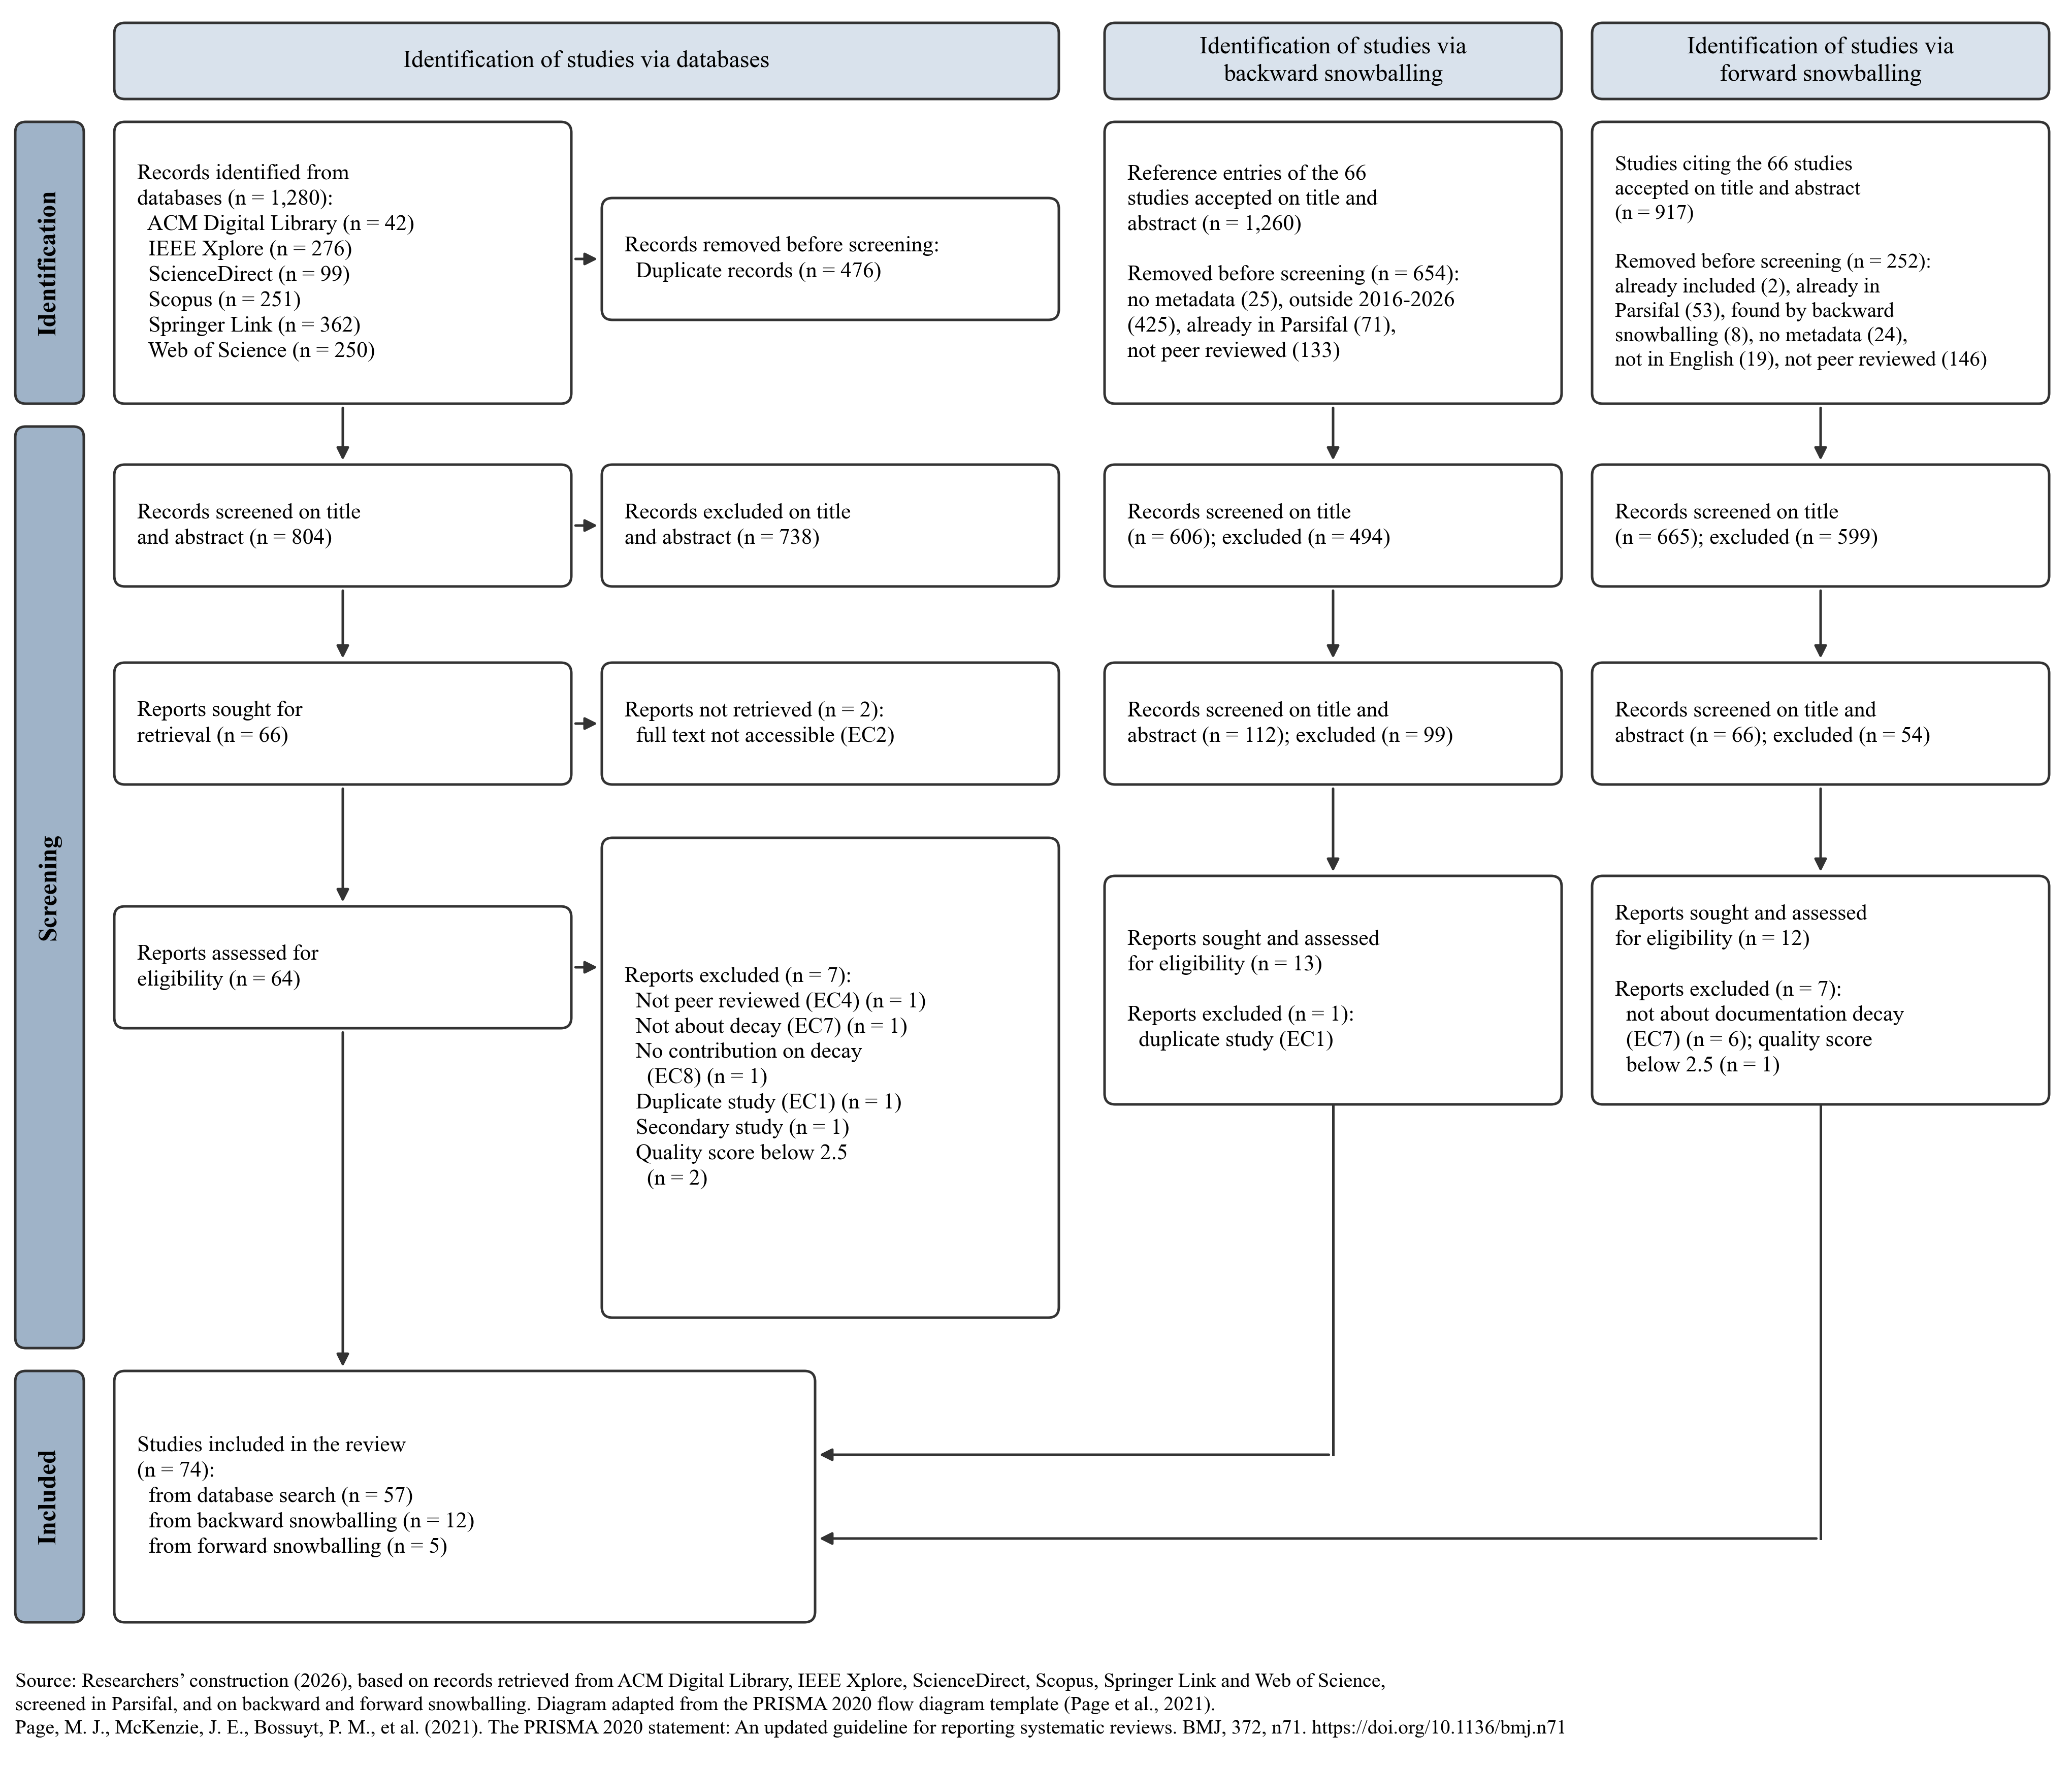

Note. Source: Researchers’ construction (2026) based on records from ACM Digital Library, IEEE Xplore, ScienceDirect, Scopus, Springer Link, and Web of Science, and on backward and forward snowballing.

3.5 Data extraction
A data extraction sheet was designed from the research questions (Table 6). Besides bibliographic data, it records the problem, data source, and project scale, research method, technique, baselines, metrics, availability, main findings, limitations, and future directions of each study, together with derived codes that allow studies to be compared and counted. The completed sheet is provided with this report.
Table 6: Data Extraction Form
Field | Content | RQ
Bibliographic data | Title, authors, year, venue and venue type | RQ1
Artifact and problem | Documentation artifact, main topic, cause of decay (own code, dependency, environment, process) | RQ1, RQ5
Data source | Dataset, data source type, number and type of projects, language | RQ2
Availability | Links to tools, datasets or replication packages and whether they still work | RQ2
Technique | Task (detection, update, detection and repair, prevention) and approach family | RQ3
Evaluation | Research method, baselines and metrics | RQ4
Outcomes | Main findings stated by the authors | RQ5
Limitations and future work | Reported limitations and future directions, coded into categories | RQ6
Quality | Answers to the five quality questions | All
Source: Researchers’ construction (2026)
LLM-assisted extraction. Following recent work on LLM-supported extraction for secondary studies [87], a large language model extracted the fields from the full texts, and the researchers verified a sample manually. Each researcher checked six randomly selected studies, 12 in total (16% of the final set), against the original papers. All 12 rows contained at least one error or omission: in every row, some detail was missing, mainly in datasets, baselines, metrics, availability, and limitations; two rows contained a factual error; and three quality scores for artifact availability were raised. No inclusion decision changed. Because the omissions were systematic, these five fields and the availability score were re-extracted for all remaining studies from the method, evaluation, and threats sections of each paper. The fields added later (main findings, future directions, data source, and project scale) were extracted from the abstracts, conclusions, and future-work sections and checked against the dataset and limitations fields already verified. The five studies added by forward snowballing were extracted in the same way, and a researcher checked their extraction against the full texts.

3.6 Analysis and synthesis
The extracted data were coded into categories for artifact, data source, task, approach family, research method, limitation, and future direction, which emerged from the data. Counts and cross-tabulations were used for RQ1 to RQ4 and RQ6, with four periods (2016–2019, 2020–2022, 2023–2024, and 2025–2026) to show change over time. For the shift in research focus, a term co-occurrence map of titles and abstracts was built in VOSviewer 1.6.21 [88] (binary counting, minimum five occurrences, largest connected component, a thesaurus that removed 56 generic terms and merged 12 synonyms). Performance was compared only among studies that used the same benchmark. RQ5 was answered by thematic synthesis of the main findings. All tool and dataset links were checked by the researchers.

4 Results
This section answers the six research questions. Each subsection gives the motivation, the approach, and the results, and ends with a summary. Primary studies are cited by reference number.

4.1 RQ1: How has research on documentation decay evolved?
Motivation. The volume, venues, and artifacts of the research show whether documentation decay is an established topic and where its focus lies. Approach. Studies were counted by year, venue, and artifact, and the term map was used to trace shifts in focus.
Results. Research on documentation decay has grown steadily, from 11 studies in 2016–2019 to 18 in 2020–2022, 19 in 2023–2024, and 26 in 2025–2026, with a peak of 15 studies in 2025 (Figure 2); the 2026 count covers only part of the year. Most studies appeared at conferences (49, 66%), 24 in journals, and one in a magazine [9]. Five venues account for 35 studies: ICSE (nine), ASE (eight), IEEE Transactions on Software Engineering (seven), ICPC (six), and ACM TOSEM (five), all leading software engineering venues.
Figure 2: Primary Studies per Publication Year, by Documentation Artifact
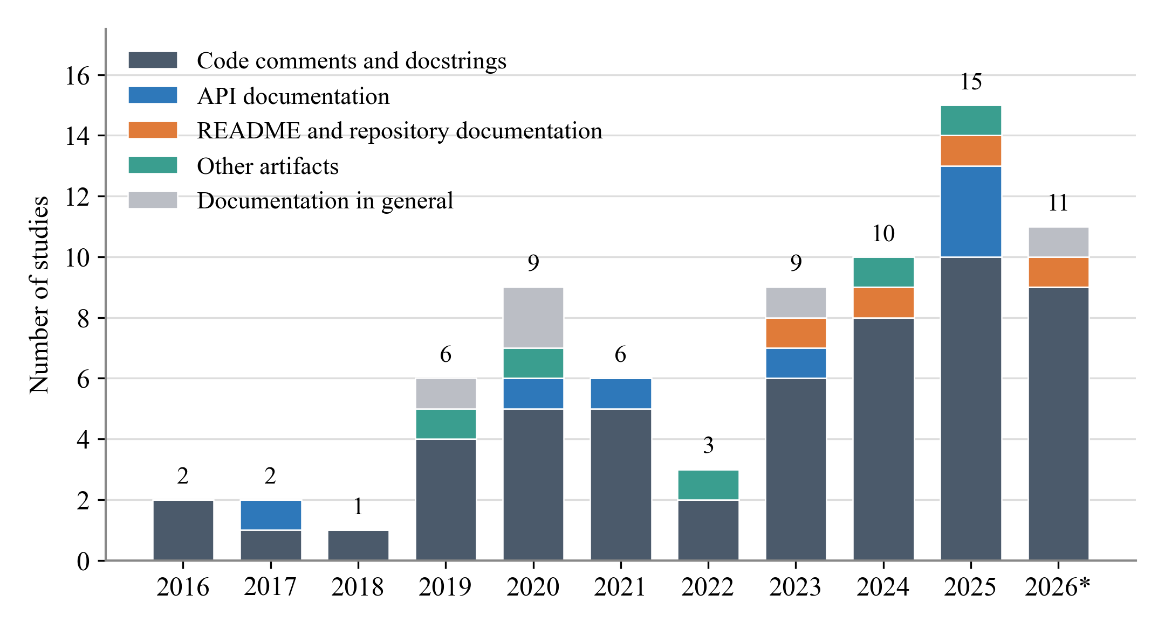
Note. Source: Researchers’ construction (2026) from the 74 included primary studies. * 2026 covers publications available up to November 2026.

Code comments dominate throughout: 53 studies (72%) address code comments or docstrings, 7 API documentation, 4 README or repository documentation, 5 other artifacts (CLI examples, BDD specifications, UML designs, GUI screenshots, and tutorials), and 5 documentation in general. The focus has nevertheless shifted. All README studies appeared from 2023 onward [8, 9, 55, 69], combined detection and repair grew to six studies in 2025–2026, and the term map shows three topic clusters (Figure 3 and Table 7): an established cluster on comment updating with mined datasets, a cluster on documentation in development practice, and the newest and now largest cluster on inconsistency detection with large language models, in which the term large language model has an average publication year of 2025. No study addressed EULAs, although they were within the search scope.
Figure 3: Term Co-occurrence Map of the Titles and Abstracts of the 74 Studies
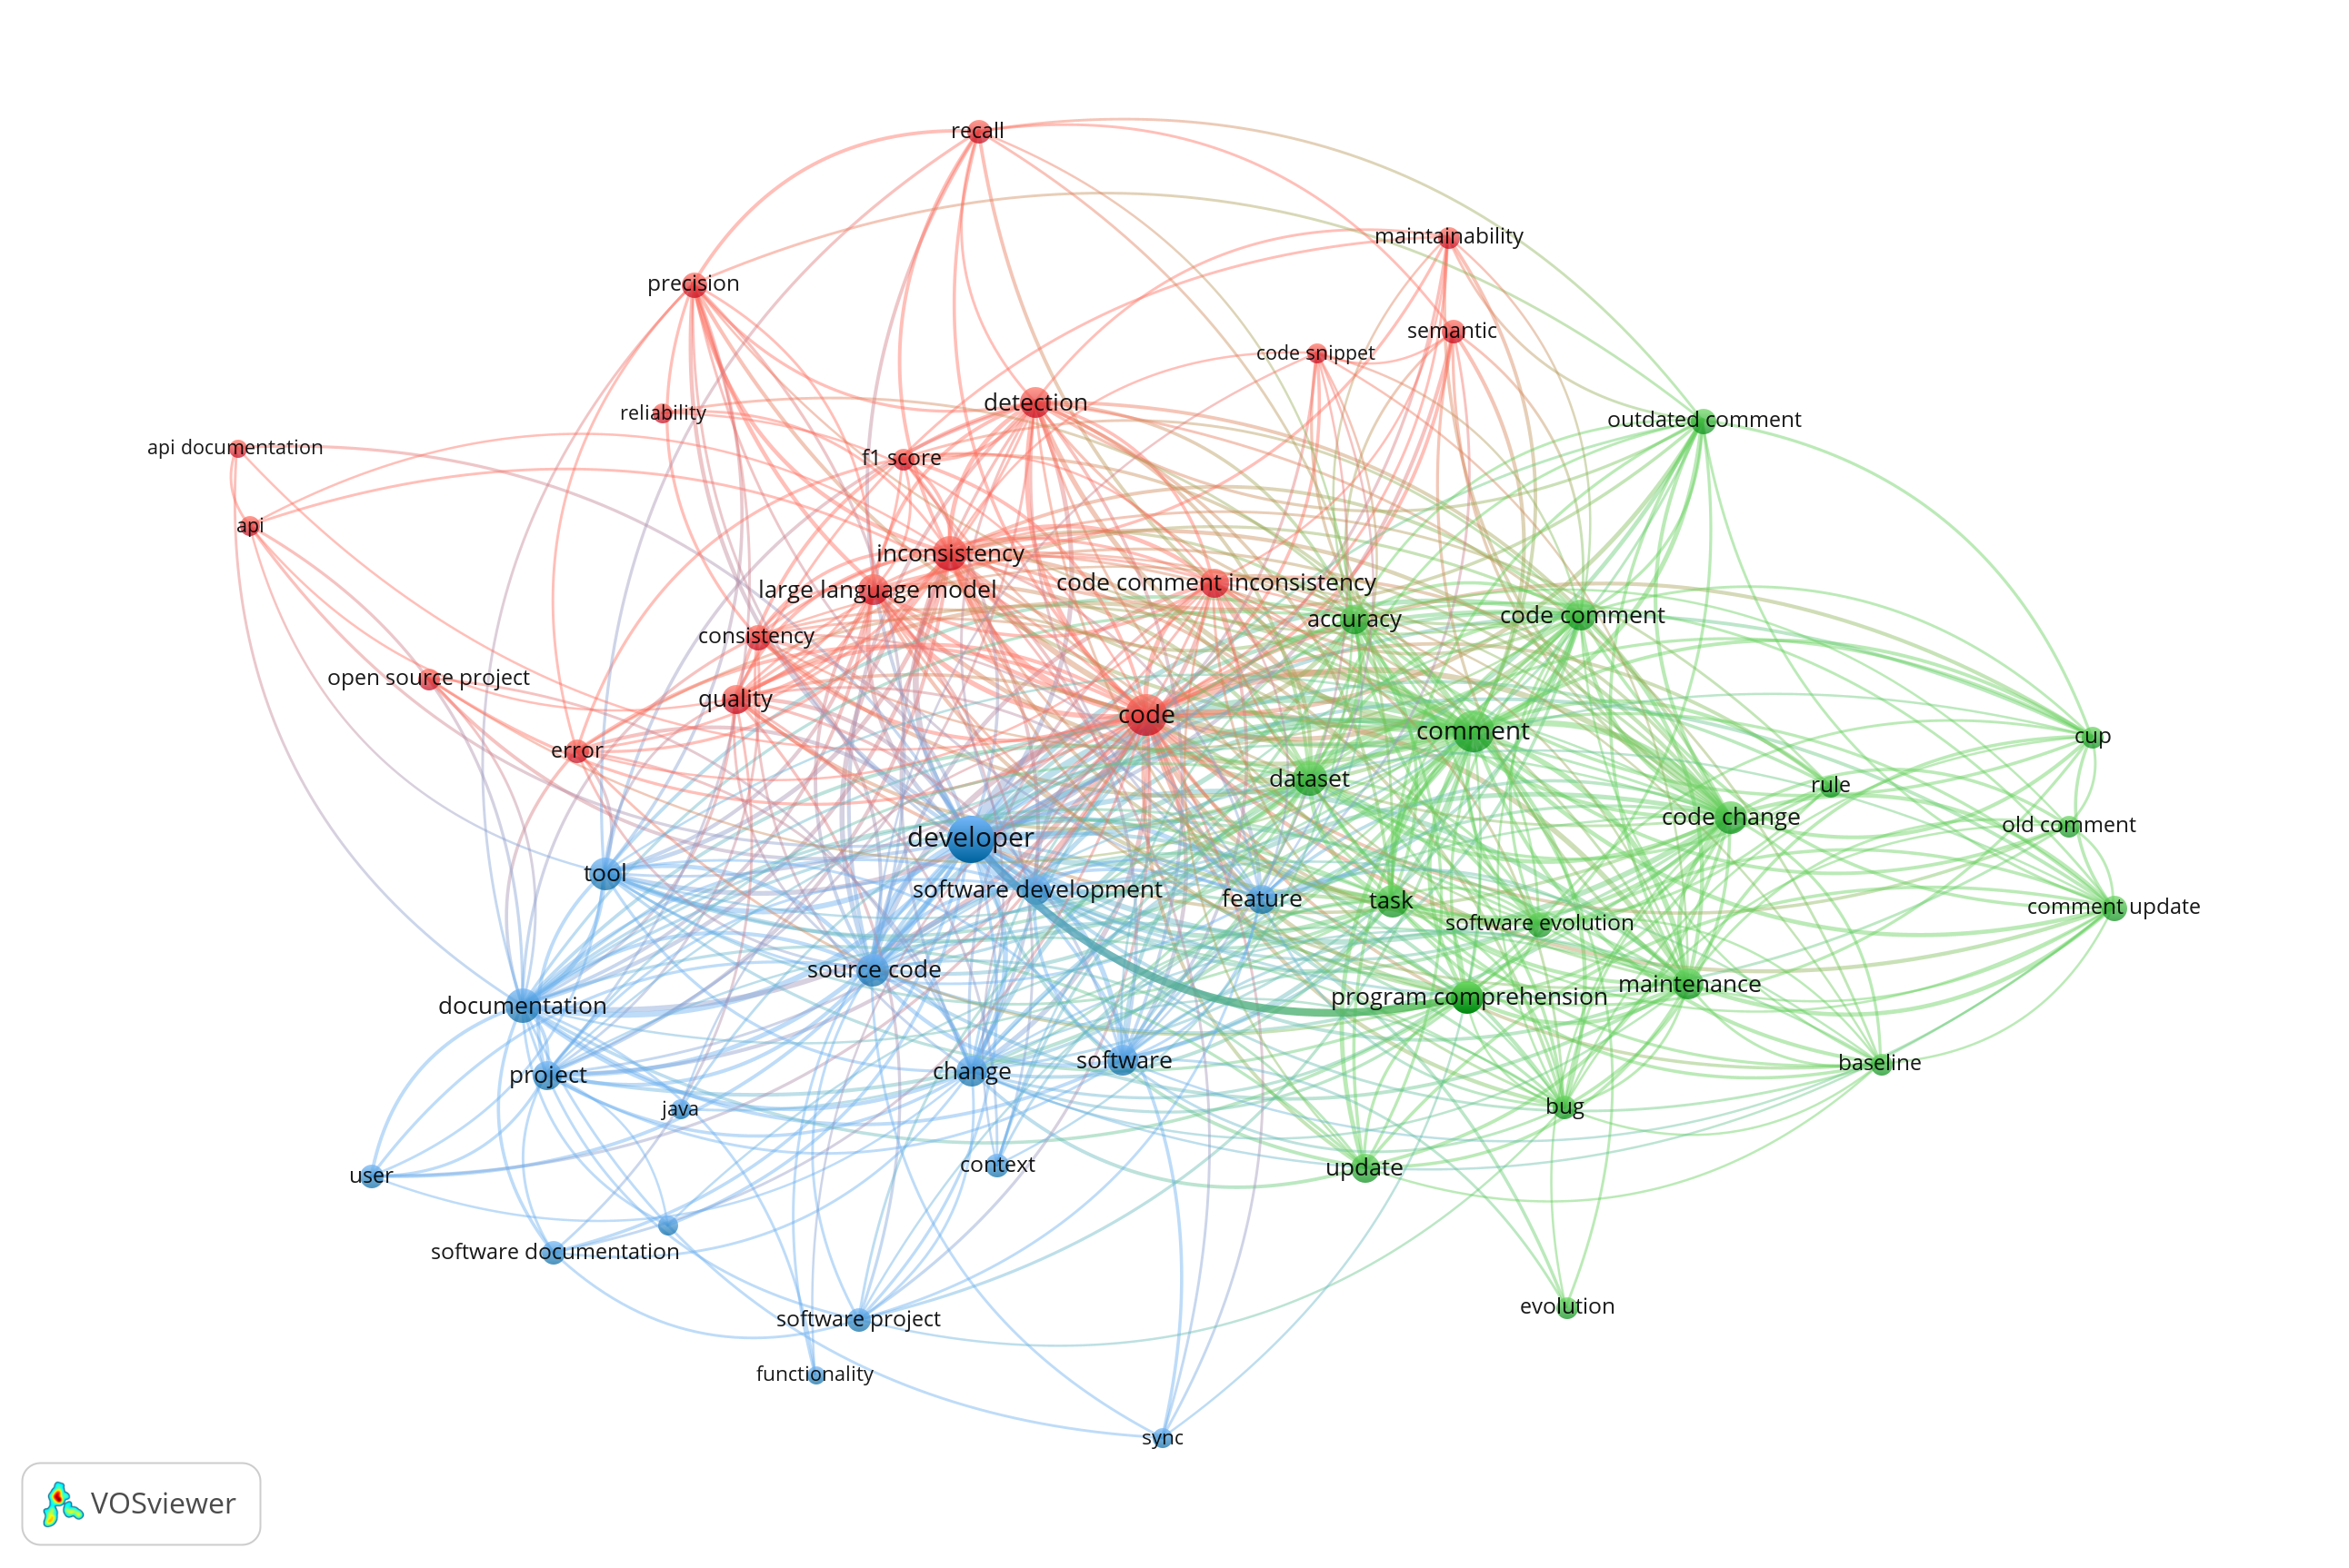

VOS viewer 1.6.21, binary counting, terms occurring in at least five studies (53 terms), largest connected component. Circle size shows how many studies use a term, colours show the clusters in Table 7, and terms that appear together more often are placed closer and linked by lines. Source: Researchers’ construction (2026) from the 74 included primary studies.
Table 7: Topic Clusters in the Term Co-occurrence Map
Cluster | Most frequent terms | Interpretation
1 (red, 18 terms) | code, inconsistency, detection, large language model, quality, code comment inconsistency, precision, recall | Inconsistency detection, increasingly with LLMs
2 (green, 18 terms) | comment, dataset, code change, maintenance, code comment, update, outdated comment, comment update | Updating comments after code changes
3 (blue, 17 terms) | developer, documentation, source code, tool, change, software, software development, project | Documentation in development practice
Source: Researchers’ construction (2026) from the 74 included primary studies.
Summary for RQ1. Research on documentation decay is growing, from 11 studies in 2016–2019 to 26 in 2025–2026, and is published mainly at leading software engineering conferences. Code comments dominate (72%); README studies emerged only after 2023, and the newest research focuses on inconsistency detection and repair with large language models.

4.2 RQ2: Which datasets and data sources are used?
Motivation: The data behind the studies determine how far their findings generalise and whether others can build on them. Approach. Each study’s data source was coded by type, the number of projects was recorded, and dataset reuse and public availability were traced.
Results: Two kinds of data dominate (Table 8). 33 studies mine new data from open-source repositories, mostly GitHub, and 30 reuse or derive from an existing benchmark. Only five studies use library or API documentation directly [6, 23, 57, 71, 77], two use practitioner surveys or interviews [36, 41], three use industrial data from Ericsson [54], Microsoft Azure [48], and Nokia [92], and one uses web tutorials [37]. The scale of mined data varies widely: eight studies analyse ten projects or fewer, while seven analyse more than 1,000, up to 25,000 repositories [33]. Java dominates: 42 studies (57%) use only Java, and Python, Rust, Solidity, and C appear in few studies.
Table 8: Data Sources and Scale of the Primary Studies
Data source | Studies | Examples
Mined from open-source repositories | 33 | GitHub commit histories, READMEs, smart contracts, Linux kernel [5, 8, 9, 82]
of which 1–10 projects | 8 | [29–31]
of which 11–100 projects | 7 | [45, 46, 70, 93, 95]
of which 101–1,000 projects | 6 | [9, 55, 69]
of which more than 1,000 projects | 7 | [5, 8, 21, 33]
number not stated or not applicable | 5 | [4, 7, 38]
Existing benchmark, reused or derived | 30 | CUP, JITDATA, OCD, Corazza et al. (Table 9)
Library or API documentation | 5 | JDK, Android, Solidity and Python data science libraries
Practitioner surveys or interviews | 2 | 146 and 39 practitioners
Industrial data | 3 | Ericsson bug reports; Azure CLI telemetry; Nokia SDK documentation
Web tutorials | 1 | 663 software tutorials
Source: Researchers’ construction (2026) from the 74 included primary studies.

A few datasets are used repeatedly (Table 9). Sixteen studies use datasets built from the 1,496 Java projects collected by Wen et al. [5], mostly the CUP comment-updating dataset [21], twelve use JITDATA [10], and four use the Corazza et al. coherence dataset [28]. Every other dataset is used by a single study, including all README, API documentation, Rust, Solidity, and Python datasets. Two studies found label noise in the common benchmarks and released cleaned versions [22, 86].
Table 9: Commonly Used Benchmark Datasets
Dataset | Studies | Primary studies
Datasets from the 1,496 Java projects of Wen et al. (CUP, OCD and cleaned versions) | 16 | [21, 22, 42, 44, 49, 51, 52, 53, 56, 58, 68, 72, 75, 78, 83, 84]
JITDATA, the just-in-time inconsistency dataset of Panthaplackel et al. | 12 | [10, 47, 59, 64, 66, 67, 74, 80, 81, 84, 86, 95]
Comment coherence dataset of Corazza et al. | 4 | [32, 39, 40, 60]
CCIBench, a cleaned version of JITDATA | 2 | [81, 86]
Counts include studies that introduced, reused, or cleaned the dataset. Source: Researchers’ construction (2026) from the 74 included primary studies.
Availability: 50 studies (68%) link to a public tool, dataset, or replication package, five mention one without a link, and 19 provide nothing. When checked on 8 November 2026 (13 November 2026 for the five studies added by forward snowballing), 43 links worked, and seven did not: three GitHub repositories had been removed [51, 65, 75], three anonymous review repositories had expired [77, 78, 92], and one website refused connections [34]. Archives such as Zenodo and figshare were all still reachable. The most reusable resources are the comment-updating and inconsistency datasets [10, 21, 52], the README tools DOCER [8, 55] and Docable [37], the API documentation tools DRONE [6] and FreshDoc [7], CoDocBench [73], and the CASCADE and DocPrism datasets [93, 95].
Summary for RQ2. Studies either mine open-source repositories (33) or reuse a small set of Java benchmarks (30); 16 studies rely on data from the same 1,496 projects. Industrial, practitioner and non-Java data are rare, and every README and API dataset is used only once. Two thirds of studies share artifacts, but seven links are already broken.

4.3 RQ3: Which techniques are used?
Motivation: Classifying techniques show which tasks are solved and how approaches change. Approach. Each study was coded by task and approach family, and the families were compared across the four periods.
Results. Detection is the most common task (34 studies), followed by updating (18), combined detection and repair (10), and prevention (one study, which turns TODO comments into executable checks [34]); 11 studies are empirical (Table 10). Detection relies equally on rule-based or program-analysis techniques and on deep learning (10 of 34 each), with rules favoured for API documentation [6, 7, 23, 57] and README files [8, 55], where documentation can be checked against concrete code elements. Updating relies mostly on deep learning (9 of 18), framed as generating a new comment from the old comment and the code change.
Table 10: Task by Approach Family
Task | Rule-based | Trad. ML | Deep learning | Hybrid | LLM | Empirical | Total
Detection | 10 | 5 | 10 | 6 | 2 | 1 | 34
Update | 1 | 0 | 9 | 3 | 5 | 0 | 18
Detection and repair | 2 | 0 | 1 | 1 | 6 | 0 | 10
Prevention | 1 | 0 | 0 | 0 | 0 | 0 | 1
Empirical study | 0 | 0 | 0 | 0 | 1 | 10 | 11
Total | 14 | 5 | 20 | 10 | 14 | 11 | 74
Six of the ten hybrid approaches combine a large language model with program analysis or test execution [65, 77, 82, 85, 93, 94]. Source: Researchers’ construction (2026) from the 74 included primary studies.

Comparing periods shows a clear progression (Figure 4). Before 2020, studies relied on rules, program analysis, and traditional machine learning [23, 29–31]. From 2020, deep learning dominated, led by CUP [21] and just-in-time inconsistency detection [10], which later work extended with richer code representations such as AST paths and graphs [51, 58, 64, 72]. Large language models first appeared in 2024 [59], and 20 studies now involve them, either fine-tuned [74, 86], prompted [71, 79, 95], guided by an edit model or re-ranking [78, 84], combined with program analysis so that the LLM extracts constraints and analysis verifies them [65, 77, 85], or checked by executing generated tests [93, 94].
Figure 4: Approach Families by Publication Period
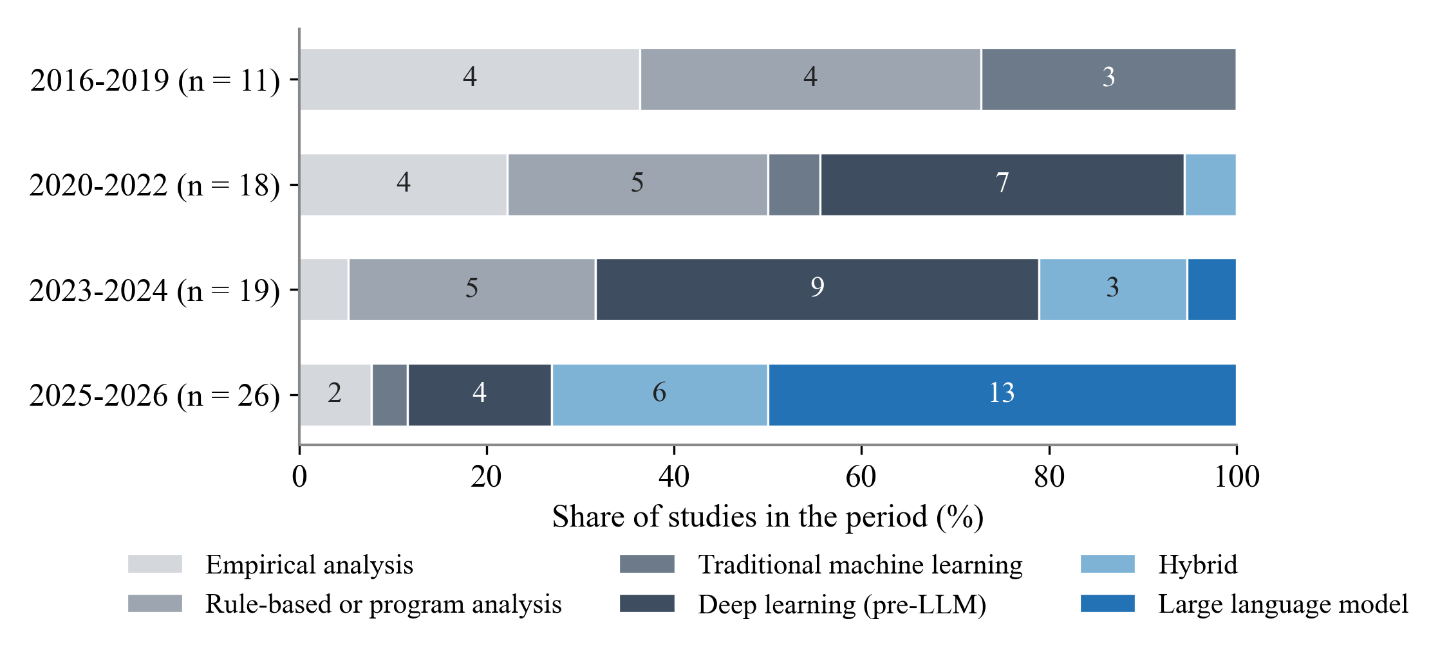
Note. Numbers in the bars are study counts. Source: Researchers’ construction (2026) from the 74 included primary studies.
Summary for RQ3. Detection is the most common task and prevention is almost unexplored. Approaches moved from rules and traditional machine learning to deep learning after 2020 and to large language models since 2024, increasingly combined with program analysis or test execution; rules remain the main approach for API and README documentation.

4.4 RQ4: How are the approaches evaluated?
Motivation: Evaluation practice determines how much the reported results can be trusted and compared. Approach. Research methods, baselines, and metrics were coded, and results were compared within shared benchmarks.
Results: Most studies (61) evaluate a technique in a benchmark experiment; 13 of them also validate it in the field by reporting detected problems to developers, who confirmed or fixed them, for example, 50 of 75 Linux patches [82], 29 of 40 Solidity documentation errors [57], 10 of 13 inconsistencies found by CASCADE [93], and 75% of FreshDoc suggestions [7]. The other studies use repository mining (6), surveys or interviews (2), industrial case studies (3), a controlled experiment with LLMs, and a study of web tutorials. Of the 63 technique studies, 18 report no baseline comparison. The most frequent baselines are CUP (10 studies), JITDATA models (8), GPT models (8), HebCUP, OCD, and Random Forest (6 each).
Measures follow the task (Figure 5). Detection studies use classification measures: precision in 24 of 34, recall in 21, F1 in 18, and accuracy in 14. Update studies use exact match (accuracy) in 10 of 18, BLEU in 9, Recall@5, METEOR, and edit distance in 8 each, and SARI in 6. Text-similarity measures reward closeness to a reference comment rather than correctness. Only 22 studies (30%) include a human or developer evaluation.
Figure 5: Evaluation Measures Reported by the Primary Studies
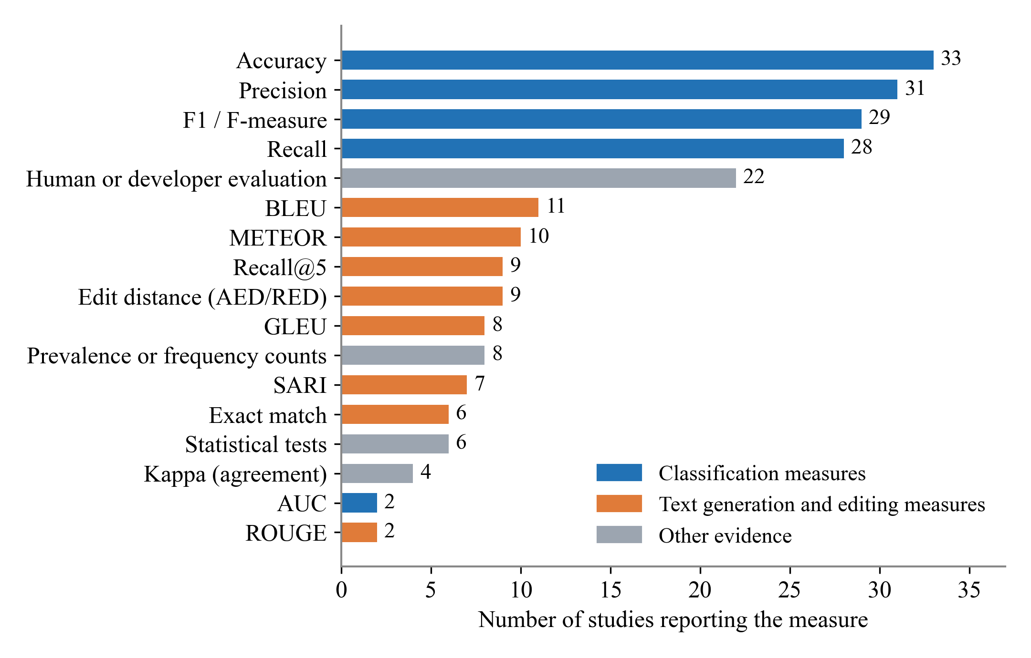
Note. A study can report several measures. Source: Researchers’ construction (2026) from the 74 included primary studies.
Performance can be compared only within shared benchmarks, and only as reported by the authors (Table 11). On the CUP dataset, the neural updater CUP reproduced developers’ comments exactly in 16.7% of cases [21]; the simple heuristic HebCUP improved accuracy by more than 60% [44], and later models report further relative gains [49, 56, 72]. On JITDATA and its cleaned version, reported F1 scores rose to 82.6% [63] and 89.5% [86], a structured-diff model outperformed fine-tuned LLMs [81], and the LLM-based DocPrism came close to the state-of-the-art C4RLLaMA [74] on JITDATA (precision 0.78 vs 0.83) but far exceeded it on real-world pairs (0.58 vs 0.08) [95]. Because studies use different cleaned versions and splits of these datasets, the figures indicate trends rather than a strict ranking.
Table 11: Reported Performance on Shared Benchmarks
Benchmark and task | Study (approach) | Reported result
CUP dataset, comment updating | CUP (deep learning) [21] | Exact match 16.7%
 | HebCUP (heuristic) [44] | Accuracy more than 60% higher than CUP, 1,700 times faster
 | HatCUP (deep learning) [49] | Accuracy 53.8% higher than CUP
 | CBS (hybrid) [56] | Accuracy 23.5% higher than CUP and HebCUP
 | MS-CUP (deep learning) [72] | Accuracy at least 5.3% higher than prior methods
OCD dataset, obsolete-comment detection | (adversarial learning) [22] | Accuracy up to 18.1% higher than OCD
 | OutComDeter (deep learning) [75] | F1 11.5% higher than OCD
JITDATA, inconsistency detection | MCCL (deep learning) [63] | F1 82.6%, 2.4–28.0% above prior methods
 | SEOCD (deep learning) [67] | F1 4.6% higher than the state of the art
 | CARL-CCI (small model) [81] | F1 up to 13.5% higher; 4.2–10.9% above fine-tuned LLMs
 | DocPrism (LLM) [95] | Precision 0.78 vs 0.83 for C4RLLaMA [74]; 0.58 vs 0.08 on real-world Java pairs
CCIBench (cleaned JITDATA) | CCISolver (LLM) [86] | F1 89.5%; 65% fixing success (human)
Relative improvements are as reported by each study against its own baselines. Source: Researchers’ construction (2026) from the 74 included primary studies.
Summary for RQ4. Most techniques are evaluated in benchmark experiments with precision, recall and F1 (detection) or exact match and BLEU (updating); 13 studies add field validation with developers, but only 30% involve any human evaluation and 18 of 63 technique studies lack a baseline. Results are comparable only within the CUP and JITDATA benchmarks, where reported performance has risen steadily.

4.5 RQ5: What are the main findings across the studies?
Motivation: Beyond techniques and metrics, the studies together say something about the nature of decay and the effectiveness of remedies. Approach. The main findings extracted for each study were grouped into themes.
Results. Six findings recur across the studies:
- Decay is common. Almost 10% of links in source code comments are dead [33]; more than a quarter of the 1,000 most popular GitHub projects contain outdated code element references [8, 55]; about one in six executable README instructions is broken [9]; 11% of 1,991 developer-written function–documentation pairs contain incorrectness inconsistencies [95]; 62% of Javadoc comments depend on indirectly associated code [46]; more than half of renamed identifiers leave fragile comments [30]; and at Ericsson 318 of 1,663 bug reports were pure documentation defects [54].
- Decay is triggered by specific changes and is rarely repaired. Particular code changes, such as changes to selection statements, trigger comment updates [5]; links are rarely updated while their targets evolve [33]; and README failures are systematic and seldom fixed [9].
- Detection works on real projects. Tools found problems that developers confirmed and fixed in Java, C#, Python, Rust, Solidity, and the Linux kernel [7, 8, 43, 57, 65, 77, 82, 85, 93], with precision of about 80% or higher where it was measured [23, 50, 70, 93].
- Automatic updating remains hard. Generated comments match developers’ updates in a minority of cases (16.7% for CUP, 41.8% for CUP2) [21, 52], and even LLM-based repair is judged correct in only 56–65% of cases [74, 86]. Simple heuristics remain competitive [44].
- Data quality matters. Benchmarks mined from commit histories contain noisy labels, and cleaning them alone improves models [22, 63, 80, 86].
- Large language models help unevenly. Larger models are not always better [68], plain prompting flags over 90% of functions as inconsistent unless its output is filtered [95], small structured models can beat fine-tuned LLMs [81], LLM updates of API documentation approach human updates [71], and outdated comments in the prompt can mislead LLM code generation [83].
Summary for RQ5. The studies agree that documentation decay is common and rarely repaired, and that detection tools find real problems that developers fix. Automatic updating remains hard, benchmark quality strongly affects results, and the benefit of large language models is still inconsistent.

4.6 RQ6: Which limitations and open problems remain?
Motivation: The limitations the authors report, and the future work they propose, show what the field itself sees as unresolved. Approach. Reported limitations and future directions were coded into categories and counted (Table 12).
Table 12: Reported Limitations and Future Directions
Reported limitation | Studies | Reported future direction | Studies
Single language or ecosystem | 48 | Improve the technique | 27
Limited data or few projects | 24 | Cover more artifacts or change types | 18
Labelling or ground-truth quality | 23 | More or cleaner data | 15
Narrow scope of artifact or change type | 20 | Integrate into tools or workflows | 12
Limited evaluation (short paper, no baseline) | 16 | Other languages | 12
LLM-specific (data leakage, cost, nondeterminism) | 13 | Studies with developers | 8
Dependence on external tools or implementation | 13 | Move from detection to repair | 4
 |  | Use context beyond the method | 3
A study can report several. 7 studies state no future direction. Source: Researchers’ construction (2026) from the 74 included primary studies.
Results: The most common limitation is reliance on a single language or ecosystem, reported by 48 studies (65%), almost always Java. Limited data (24), labelling and ground-truth quality (23), and a narrow scope of artifact or change type (20) follow. Studies using large language models add data leakage from pre-training, cost, and nondeterminism [68, 78, 84, 86]. In their future work, authors most often plan to improve their technique (27) or extend it to more artifacts or change types (18); fewer plan to integrate tools into developer workflows (12), study other languages (12), or evaluate with developers (8). Open problems that span studies include decay caused by changes outside the method or repository [10, 46, 70], non-code-indicative comment updates [51, 58], and moved or renamed files [8, 73].
Summary for RQ6. Two thirds of the studies report that their evidence comes from a single language, and many report label noise, limited data and a narrow scope. Authors mostly plan incremental improvements; few plan studies with developers, workflow integration or other languages, and decay caused by changes outside the documented code remains open.

5 Discussion

5.1 Research trends and maturity
Taken together, the results describe a field that is growing quickly but is maturing unevenly. Research on code comments is mature in the sense that it has shared benchmarks, standard metrics, a clear line of successive techniques, and repeated replication of the same task. Research on README, API, tutorial, and design documentation is young: most of it appeared after 2020, each study uses its own data, and few build on one another. The publication venues, mainly ICSE, ASE, TSE, ICPC, and TOSEM, show that the topic is accepted in the core of software engineering research, while the concentration of work in 2025 and 2026 reflects both renewed interest and the arrival of large language models.

5.2 Methods and datasets
The research problem has broadened from detecting whether a single comment is outdated to detecting and repairing inconsistencies across artifacts, and from post hoc checks of a snapshot to just-in-time checks of each change. Techniques followed the general trend in software engineering from rules to deep learning to large language models, but with one important difference: in API and README documentation, rules and program analysis remain the strongest approach because documentation can be checked against concrete code elements, and the most recent LLM work combines the model with program analysis or test execution rather than replacing it. The datasets have not kept pace. More than a third of the studies depend on two Java benchmarks derived from the same projects, which makes results comparable but also means that much of the field’s progress has been measured on one kind of documentation in one language.

5.3 Evaluation
Evaluation differs sharply between tasks and between the two traditions. Benchmark studies of comment updating and detection report precise numbers but rely on text-similarity metrics and on labels derived automatically from commit histories, which several studies showed to be noisy. Field studies of API, README and kernel documentation report fewer numbers but stronger evidence, because developers confirmed and fixed what the tools found. Only 30% of studies include any human judgement, and 18 of 63 technique studies report no baseline. Common evaluation practice is therefore strongest where it matters least for practice, on reproducing developers’ comment edits, and weakest for the artifacts users read first.

5.4 Strength of evidence and inconsistencies
The evidence is strong that decay is common, that it accumulates because it is rarely repaired, and that detection can find real problems. It is weaker on how decay affects developers, how often it causes defects, and whether updating tools help in practice, because few studies measure these outcomes. Two inconsistencies stand out. First, deep learning updaters were long reported as the state of the art, yet a simple heuristic outperformed the first of them [44], and later studies show that cleaning the data can matter as much as the model [22, 80]. Second, studies disagree on the value of large language models: some report clear gains [71, 84, 86], while others find that larger models are not always better and that small structured models can outperform them [68, 81].

5.5 Implications for researchers and practitioners
For researchers, the results call for benchmarks beyond Java comments, for evaluations that measure correctness and usefulness rather than similarity, for strong simple baselines whenever large language models are used, and for durable archiving of artifacts. For practitioners, existing tools such as DOCER for README files and DRONE and FreshDoc for API documentation can already flag common forms of decay, and the evidence that decay is rarely repaired once introduced argues for checking documentation automatically in code review or continuous integration rather than relying on later clean-up.

6 Research Gaps and Future Directions

6.1 What has been well studied
Detection and updating of Java method comments after code changes are well studied, with shared benchmarks, many competing techniques, and established metrics. The prevalence of decay in comments and links, and rule-based detection of defects in Java API documentation, are also supported by large studies and confirmed by developers.

6.2 What has received limited attention
- Artifacts beyond comments. Only four studies address README files, seven API documentation, and none EULAs or privacy policies. New artifacts, such as instruction files for AI coding agents, are likely to decay in the same way.
- External causes of decay. Only ten studies consider changes to dependencies, APIs, or the environment, although README and API documentation decay largely for these reasons.
- Prevention. One study prevents decay [34]; the rest detect or repair it after it occurs.
- Languages and data. Forty-two studies use Java alone, and most benchmark evidence comes from the same 1,496 projects.
- Developers and practice. Few studies measure how decay affects developers or whether tools are adopted, and only three use industrial data.

6.3 Limitations future work should address
Future studies should evaluate on several languages and on cleaned, manually verified benchmarks; report strong simple baselines alongside deep learning and LLM approaches; measure correctness and usefulness with developers rather than similarity alone; control for data leakage when evaluating large language models; and archive tools and datasets on long-term services rather than on personal or anonymous repositories.

6.4 Open research questions
- How prevalent and persistent is decay in README and other repository documentation across typical, not only popular, projects?
- How can decay caused by changes in dependencies, APIs, and the environment be detected before users encounter it?
- Can checks in continuous integration prevent decay, and will developers accept them?
- Do documentation decay detectors and updaters generalise across languages and ecosystems?
- How do large language models compare with simple heuristics and program analysis when evaluated for correctness by developers?

6.5 Connection to the proposed project
These gaps motivate the researchers’ project, Docs Left Astray: Detecting and Repairing Documentation Drift, Staleness and Decay in GitHub README Files. The review shows that README documentation is the least studied artifact with direct user impact, that only four studies address it [8, 9, 55, 69], that each uses its own data, and that decay caused by external change and the persistence of decay over time are open. The project therefore measures the prevalence and persistence of README decay across typical projects (open questions 1 and 2), compares detection with the DOCER approach [8], the strongest existing baseline, and explores repair, while applying the lessons of this review: evaluation on more than one language, a manually verified ground truth, simple baselines, developer feedback and archived artifacts.

7 Threats to Validity
Threats are discussed following the categories commonly used for secondary studies [89].
Construct validity: Documentation decay is described with many terms, and relevant studies may use others. This threat was reduced by a broad string with synonyms, wildcards, and a proximity term, validated against a quasi-gold standard whose six studies were all retrieved, and by backward and forward snowballing.
Internal validity: A large language model pre-screened records and performed the first extraction. The calibration on 50 records (kappa 0.88) and the verification of 12 extractions, which led to a second extraction pass, reduce this threat, but rejections outside the calibration sample were not independently audited, and a 16% verification sample cannot rule out remaining errors. One round each of backward and forward snowballing was run; forward snowballing candidates were screened on title and abstract by one researcher and read in full by the other.
External validity: The review covers peer-reviewed English studies from 2016 to 2026. Preprints were excluded, which matters in a field where LLM work often appears first as a pre-print, the 2026 counts are incomplete, and two studies could not be accessed.

8 Conclusion
This systematic literature review analysed 74 primary studies on documentation decay published between 2016 and 2026. The field is growing and has moved from rule-based methods to deep learning and large language models. Its evidence shows that decay is common, rarely repaired, and detectable on real projects, while automatic updating remains difficult. However, the research is concentrated on Java code comments, on a few shared benchmarks, on decay caused by the documented code itself, and on evaluation by similarity rather than by developers. README, API, and legal documentation, decay caused by external change, prevention, other languages, and durable research artifacts need more attention. The researchers’ follow-up project on README documentation addresses several of these gaps.

9 Disclosure of Generative AI Use
The researchers used Claude (Anthropic) [90], a large language model. It suggested wording for the research questions and protocol, helped refine the search strings. It pre-screened all 804 records on title and abstract, retrieved the reference lists for snowballing, and made first-pass full-text decisions. Researchers controlled each step done by Claude: they defined the protocol and criteria; both screened a blind calibration sample of 50 records (kappa 0.88) and reviewed undecided records; researchers agreed every full-text exclusion and approved the snowballing inclusions; researchers verified 12 extractions (17%) against the original papers, all of which needed corrections, which led to the second extraction pass; and they revised and approved all text. The researchers take full responsibility for the content of this report.

References
[1] T. C. Lethbridge, J. Singer, and A. Forward, “How software engineers use documentation: The state of the practice,” IEEE Softw., vol. 20, no. 6, pp. 35–39, 2003, doi: 10.1109/MS.2003.1241364.
[2] D. L. Parnas, “Software aging,” in Proc. 16th Int. Conf. Softw. Eng. (ICSE), 1994, pp. 279–287, doi: 10.1109/ICSE.1994.296790.
[3] B. Fluri, M. Würsch, and H. C. Gall, “Do code and comments co-evolve? On the relation between source code and comment changes,” in Proc. 14th Working Conf. Reverse Eng. (WCRE), 2007, pp. 70–79, doi: 10.1109/WCRE.2007.21.
[4] E. Aghajani et al., “Software Documentation Issues Unveiled,” in ACM/IEEE International Conference on Software Engineering: Companion Proceedings (ICSE-Companion), 2019, doi: 10.1109/icse.2019.00122.
[5] F. Wen, C. Nagy, G. Bavota, and M. Lanza, “A Large-Scale Empirical Study on Code-Comment Inconsistencies,” in 2019 IEEE/ACM 27th International Conference on Program Comprehension (ICPC), 2019, doi: 10.1109/icpc.2019.00019.
[6] Y. Zhou, C. Wang, X. Yan, T. Chen, S. Panichella, and H. Gall, “Automatic Detection and Repair Recommendation of Directive Defects in Java API Documentation,” IEEE Transactions on Software Engineering, 2020, doi: 10.1109/tse.2018.2872971.
[7] S. Lee, R. Wu, S. C. Cheung, and S. Kang, “Automatic Detection and Update Suggestion for Outdated API Names in Documentation,” IEEE Transactions on Software Engineering, 2021, doi: 10.1109/tse.2019.2901459.
[8] W. S. Tan, M. Wagner, and C. Treude, “Detecting outdated code element references in software repository documentation,” Empirical Software Engineering, 2024, doi: 10.1007/s10664-023-10397-6.
[9] M. Kassab, “Copy, Paste, Fail: Measuring the Reliability of Executable Documentation,” IEEE Reliability Magazine, 2026, doi: 10.1109/mrl.2026.3718870.
[10] S. Panthaplackel, J. J. Li, M. Gligoric, and R. J. Mooney, “Deep Just-In-Time Inconsistency Detection Between Comments and Source Code,” Proceedings of the AAAI Conference on Artificial Intelligence, 2021, doi: 10.1609/aaai.v35i1.16119.
[11] J. Zhi, V. Garousi-Yusifoğlu, B. Sun, G. Garousi, S. Shahnewaz, and G. Ruhe, “Cost, benefits and quality of software development documentation: A systematic mapping,” J. Syst. Softw., vol. 99, pp. 175–198, 2015, doi: 10.1016/j.jss.2014.09.042.
[12] P. Rani, A. Blasi, N. Stulova, S. Panichella, A. Gorla, and O. Nierstrasz, “A decade of code comment quality assessment: A systematic literature review,” J. Syst. Softw., vol. 195, art. 111515, 2023, doi: 10.1016/j.jss.2022.111515.
[13] G. Pinho, A. J. Caçula, L. Costa, I. Wiese, and A. A. Araújo, “Challenges and solutions of free and open source software documentation: A systematic mapping study,” in Proc. 38th Brazilian Symp. Softw. Eng. (SBES), 2024, pp. 114–125, doi: 10.5753/sbes.2024.3307.
[14] A. Mohamed, M. Jan, R. Badran, S. Mohamed, Y. Amr, and N. Shorim, “A review on detecting and managing documentation drift in software development,” in Proc. Int. Mobile, Intelligent, and Ubiquitous Comput. Conf. (MIUCC), 2025, pp. 546–552, doi: 10.1109/MIUCC66482.2025.11196773.
[15] G. G. de Almeida, M. R. de Souza, and F. J. Ferreira, “API documentation-related problems: A systematic mapping study,” in Proc. 32nd Brazilian Symp. Multimedia and the Web (WebMedia), 2026, pp. 595–607, doi: 10.5753/webmedia.2026.30931.
[16] B. Kitchenham and S. Charters, “Guidelines for performing systematic literature reviews in software engineering,” Keele Univ. and Durham Univ., EBSE Tech. Rep. EBSE-2007-01, ver. 2.3, 2007. [Online]. Available: https://www.elsevier.com/__data/promis_misc/525444systematicreviewsguide.pdf
[17] B. Kitchenham, L. Madeyski, and D. Budgen, “SEGRESS: Software engineering guidelines for reporting secondary studies,” IEEE Trans. Softw. Eng., vol. 49, no. 3, pp. 1273–1298, 2023, doi: 10.1109/TSE.2022.3174092.
[18] M. J. Page et al., “The PRISMA 2020 statement: An updated guideline for reporting systematic reviews,” BMJ, vol. 372, n71, 2021, doi: 10.1136/bmj.n71.
[19] Parsifal. Accessed: Oct.–Nov. 2026. [Online]. Available: https://parsif.al
[20] H. Zhang, M. A. Babar, and P. Tell, “Identifying relevant studies in software engineering,” Inf. Softw. Technol., vol. 53, no. 6, pp. 625–637, 2011, doi: 10.1016/j.infsof.2010.12.010.
[21] Z. Liu, X. Xia, M. Yan, and S. Li, “Automating just-in-time comment updating,” in Proceedings of the 35th IEEE/ACM International Conference on Automated Software Engineering, 2020, doi: 10.1145/3324884.3416581.
[22] S. Xu, Y. Yao, F. Xu, T. Gu, J. Xu, and X. Ma, “Data Quality Matters: A Case Study of Obsolete Comment Detection,” in 2023 IEEE/ACM 45th International Conference on Software Engineering (ICSE), 2023, doi: 10.1109/icse48619.2023.00074.
[23] Y. Zhou, R. Gu, T. Chen, Z. Huang, S. Panichella, and H. Gall, “Analyzing APIs Documentation and Code to Detect Directive Defects,” in 2017 IEEE/ACM 39th International Conference on Software Engineering (ICSE), 2017, doi: 10.1109/icse.2017.11.
[24] J. Cohen, “A coefficient of agreement for nominal scales,” Educ. Psychol. Meas., vol. 20, no. 1, pp. 37–46, 1960, doi: 10.1177/001316446002000104.
[25] J. R. Landis and G. G. Koch, “The measurement of observer agreement for categorical data,” Biometrics, vol. 33, no. 1, pp. 159–174, 1977, doi: 10.2307/2529310.
[26] C. Wohlin, “Guidelines for snowballing in systematic literature studies and a replication in software engineering,” in Proc. 18th Int. Conf. Eval. Assess. Softw. Eng. (EASE), 2014, pp. 1–10, doi: 10.1145/2601248.2601268.
[27] J. Priem, H. Piwowar, and R. Orr, “OpenAlex: A fully-open index of scholarly works, authors, venues, institutions, and concepts,” arXiv:2205.01833, 2022, doi: 10.48550/arXiv.2205.01833.
[28] A. Corazza, V. Maggio, and G. Scanniello, “Coherence of comments and method implementations: a dataset and an empirical investigation,” Software Quality Journal, 2016, doi: 10.1007/s11219-016-9347-1.
[29] G. Sridhara, “Automatically Detecting the Up-To-Date Status of ToDo Comments in Java Programs,” in Proceedings of the 9th India Software Engineering Conference, 2016, doi: 10.1145/2856636.2856638.
[30] I. K. Ratol and M. P. Robillard, “Detecting fragile comments,” in 2017 32nd IEEE/ACM International Conference on Automated Software Engineering (ASE), 2017, doi: 10.1109/ase.2017.8115624.
[31] Z. Liu, H. Chen, X. Chen, X. Luo, and F. Zhou, “Automatic Detection of Outdated Comments During Code Changes,” in 2018 IEEE 42nd Annual Computer Software and Applications Conference (COMPSAC), 2018, doi: 10.1109/compsac.2018.00028.
[32] A. Cimasa, A. Corazza, C. Coviello, and G. Scanniello, “Word Embeddings for Comment Coherence,” in Euromicro Conference on Software Engineering and Advanced Applications (SEAA), 2019, doi: 10.1109/seaa.2019.00046.
[33] H. Hata, C. Treude, R. G. Kula, and T. Ishio, “9.6 Million Links in Source Code Comments: Purpose, Evolution, and Decay,” in 2019 IEEE/ACM 41st International Conference on Software Engineering (ICSE), 2019, doi: 10.1109/icse.2019.00123.
[34] P. Nie, R. Rai, J. J. Li, S. Khurshid, R. J. Mooney, and M. Gligoric, “A framework for writing trigger-action todo comments in executable format,” in ACM Joint European Software Engineering Conference and Symposium on the Foundations of Software Engineering (ESEC/FSE), 2019, doi: 10.1145/3338906.3338965.
[35] A. Z. Yang, D. Alencar da Costa, and Y. Zou, “Predicting Co-Changes between Functionality Specifications and Source Code in Behavior Driven Development,” in 2019 IEEE/ACM 16th International Conference on Mining Software Repositories (MSR), 2019, doi: 10.1109/msr.2019.00080.
[36] E. Aghajani et al., “Software documentation,” in ACM/IEEE International Conference on Software Engineering: Companion Proceedings (ICSE-Companion), 2020, doi: 10.1145/3377811.3380405.
[37] S. Mirhosseini and C. Parnin, “Docable: evaluating the executability of software tutorials,” in ACM Joint European Software Engineering Conference and Symposium on the Foundations of Software Engineering (ESEC/FSE), 2020, doi: 10.1145/3368089.3409706.
[38] S. Panthaplackel, P. Nie, M. Gligoric, J. J. Li, and R. Mooney, “Learning to Update Natural Language Comments Based on Code Changes,” in Proceedings of the conference - Association for Computational Linguistics. Meeting, 2020, doi: 10.18653/v1/2020.acl-main.168.
[39] F. Rabbi, M. Nazmul Haque, M. Eusha Kadir, M. Saeed Siddik, and A. Kabir, “An ensemble approach to detect code comment inconsistencies using topic modeling,” in Proceedings of the 32nd International Conference on Software Engineering and Knowledge Engineering (SEKE), 2020, pp. 392–395. [Online]. Available: https://ksiresearch.org/seke/seke20paper/paper062.pdf
[40] F. Rabbi and M. S. Siddik, “Detecting Code Comment Inconsistency using Siamese Recurrent Network,” in Proceedings of the 28th International Conference on Program Comprehension, 2020, doi: 10.1145/3387904.3389286.
[41] N. Rios et al., “Hearing the Voice of Software Practitioners on Causes, Effects, and Practices to Deal with Documentation Debt,” in Lecture Notes in Computer Science, 2020, doi: 10.1007/978-3-030-44429-7_4.
[42] N. Stulova, A. Blasi, A. Gorla, and O. Nierstrasz, “Towards Detecting Inconsistent Comments in Java Source Code Automatically,” in 2020 IEEE 20th International Working Conference on Source Code Analysis and Manipulation (SCAM), 2020, doi: 10.1109/scam51674.2020.00012.
[43] Z. Gao, X. Xia, D. Lo, J. Grundy, and T. Zimmermann, “Automating the removal of obsolete TODO comments,” in Proceedings of the 29th ACM Joint Meeting on European Software Engineering Conference and Symposium on the Foundations of Software Engineering, 2021, doi: 10.1145/3468264.3468553.
[44] B. Lin, S. Wang, K. Liu, X. Mao, and T. F. Bissyande, “Automated Comment Update: How Far are We?,” in 2021 IEEE/ACM 29th International Conference on Program Comprehension (ICPC), 2021, doi: 10.1109/icpc52881.2021.00013.
[45] W. Ouyang and B. Hua, “′R: Towards Detecting and Understanding Code-Document Violations in Rust,” in IEEE International Symposium on Software Reliability Engineering Workshops (ISSREW), 2021, doi: 10.1109/issrew53611.2021.00063.
[46] D. Sondhi, A. Gupta, S. Purandare, A. Rana, D. Kaushal, and R. Purandare, “On Indirectly Dependent Documentation in the Context of Code Evolution: A Study,” in 2021 IEEE/ACM 43rd International Conference on Software Engineering (ICSE), 2021, doi: 10.1109/icse43902.2021.00134.
[47] S. Guo, X. Xu, H. Li, and R. Chen, “Deep Just-In-Time Consistent Comment Update via Source Code Changes,” in 2022 IEEE 13th International Symposium on Parallel Architectures, Algorithms and Programming (PAAP), 2022, doi: 10.1109/paap56126.2022.10010469.
[48] R. Z. Moghaddam, S. Garg, C. B. Clement, Y. Mohylevskyy, and N. Sundaresan, “Generating Examples from CLI Usage: Can Transformers Help?,” in Proceedings of the 28th ACM SIGKDD Conference on Knowledge Discovery and Data Mining, 2022, doi: 10.1145/3534678.3549983.
[49] H. Zhu, X. He, and L. Xu, “HatCUP: Hybrid Analysis and Attention based Just-In-Time Comment Updating,” in Proceedings of the 30th IEEE/ACM International Conference on Program Comprehension, 2022, doi: 10.1145/3524610.3527901.
[50] S. Hao, Y. Nan, Z. Zheng, and X. Liu, “SmartCoCo: Checking Comment-Code Inconsistency in Smart Contracts via Constraint Propagation and Binding,” in 2023 38th IEEE/ACM International Conference on Automated Software Engineering (ASE), 2023, doi: 10.1109/ase56229.2023.00142.
[51] B. Lin, S. Wang, Z. Liu, X. Xia, and X. Mao, “Predictive Comment Updating With Heuristics and AST-Path-Based Neural Learning: A Two-Phase Approach,” IEEE Transactions on Software Engineering, 2023, doi: 10.1109/tse.2022.3185458.
[52] Z. Liu, X. Xia, D. Lo, M. Yan, and S. Li, “Just-In-Time Obsolete Comment Detection and Update,” IEEE Transactions on Software Engineering, 2023, doi: 10.1109/tse.2021.3138909.
[53] S. Liu, Z. Cui, X. Chen, J. Yang, L. Li, and L. Zheng, “TBCUP: A Transformer-based Code Comments Updating Approach,” in 2023 IEEE 47th Annual Computers, Software, and Applications Conference (COMPSAC), 2023, doi: 10.1109/compsac57700.2023.00119.
[54] L. Silva, M. Unterkalmsteiner, and K. Wnuk, “Towards identifying and minimizing customer-facing documentation debt,” in 2023 ACM/IEEE International Conference on Technical Debt (TechDebt), 2023, doi: 10.1109/techdebt59074.2023.00015.
[55] W. S. Tan, M. Wagner, and C. Treude, “Wait, wasn’t that code here before? Detecting Outdated Software Documentation,” in 2023 IEEE International Conference on Software Maintenance and Evolution (ICSME), 2023, doi: 10.1109/icsme58846.2023.00071.
[56] Z. Yang, J. W. Keung, X. Yu, Y. Xiao, Z. Jin, and J. Zhang, “On the Significance of Category Prediction for Code-Comment Synchronization,” ACM Transactions on Software Engineering and Methodology, 2023, doi: 10.1145/3534117.
[57] C. Zhu, Y. Liu, X. Wu, and Y. Li, “Identifying Solidity Smart Contract API Documentation Errors,” in Proceedings of the 37th IEEE/ACM International Conference on Automated Software Engineering, 2023, doi: 10.1145/3551349.3556963.
[58] Y. Chen, Y. Huang, X. Chen, and Z. Zheng, “TG-CUP: A Transformer and GNN-Based Multi-Modal Comment Updating Method,” ACM Transactions on Software Engineering and Methodology, 2024, doi: 10.1145/3708474.
[59] A. Dau, J. L. Guo, and N. Bui, “DocChecker: Bootstrapping Code Large Language Model for Detecting and Resolving Code-Comment Inconsistencies,” in Proceedings of the 18th Conference of the European Chapter of the Association for Computational Linguistics: System Demonstrations, 2024, doi: 10.18653/v1/2024.eacl-demo.20.
[60] M. D. Igbomezie, P. T. Nguyen, and D. Di Ruscio, “When simplicity meets effectiveness: Detecting code comments coherence with word embeddings and LSTM,” in International Conference on Evaluation and Assessment in Software Engineering (EASE), 2024, doi: 10.1145/3661167.3661187.
[61] X. Liu, S. Hao, L. Yang, and X. Shi, “Towards Detecting Comment-Code Inconsistency in Smart Contract via Pre-Training Techniques,” in 2024 IEEE International Conference on Security, Privacy, Anonymity in Computation and Communication and Storage (SpaCCS), 2024, doi: 10.1109/spaccs63173.2024.00013.
[62] J. Romeo, M. Raglianti, C. Nagy, and M. Lanza, “Capturing and Understanding the Drift Between Design, Implementation, and Documentation,” in Proceedings of the 32nd IEEE/ACM International Conference on Program Comprehension, 2024, doi: 10.1145/3643916.3644399.
[63] Z. Xu et al., “Code Comment Inconsistency Detection Based on Confidence Learning,” IEEE Transactions on Software Engineering, 2024, doi: 10.1109/tse.2024.3358489.
[64] H. Yang, H. Chen, Z. Kuai, S. Tu, and L. Kuang, “ASKDetector: An AST-Semantic and Key Features Fusion based Code Comment Mismatch Detector,” in Proceedings of the 32nd IEEE/ACM International Conference on Program Comprehension, 2024, doi: 10.1145/3643916.3644405.
[65] Y. Zhang, Z. Liu, Y. Feng, and B. Xu, “Leveraging Large Language Model to Assist Detecting Rust Code Comment Inconsistency,” in Proceedings of the 39th IEEE/ACM International Conference on Automated Software Engineering, 2024, doi: 10.1145/3691620.3695010.
[66] L. Zhao, W. Zhao, H. Li, S. Guo, and L. Hao, “Source Code Changes Just-in-Time Update via Code Semantics,” in 2024 14th International Conference on Information Science and Technology (ICIST), 2024, doi: 10.1109/icist63249.2024.10805465.
[67] Z. Cui, S. Liu, L. Li, and L. Zheng, “SEOCD: Detecting obsolete code comments by fusing semantic features and expert features,” Expert Systems with Applications, 2025, doi: 10.1016/j.eswa.2025.127470.
[68] L. Fan, J. Liu, Z. Liu, D. Lo, X. Xia, and S. Li, “Exploring the Capabilities of LLMs for Code-Change-Related Tasks,” ACM Transactions on Software Engineering and Methodology, 2025, doi: 10.1145/3709358.
[69] H. Gao, C. Treude, and M. Zahedi, “Adapting Installation Instructions in Rapidly Evolving Software Ecosystems,” IEEE Transactions on Software Engineering, 2025, doi: 10.1109/tse.2025.3552614.
[70] Y. Huang, Y. Chen, X. Chen, and X. Zhou, “Are your comments outdated? Toward automatically detecting code‐comment consistency,” Journal of Software: Evolution and Process, 2025, doi: 10.1002/smr.2718.
[71] S. Lee, J. Heo, and K. R. Dearstyne, “Can LLMs Update API Documentation?,” in 2025 IEEE International Conference on Software Maintenance and Evolution (ICSME), 2025, doi: 10.1109/icsme64153.2025.00048.
[72] J. Li, C. Ma, W. Lin, and Z. Zhang, “MS-CUP: A Multi-Source Code Comment Updating Method,” in 2025 IEEE/ACIS 29th International Conference on Software Engineering, Artificial Intelligence, Networking and Parallel/Distributed Computing (SNPD), 2025, doi: 10.1109/snpd65828.2025.11253856.
[73] K. Pai, P. Devanbu, and T. Ahmed, “CoDocBench: A Dataset for Code-Documentation Alignment in Software Maintenance,” in International Conference on Mining Software Repositories (MSR), 2025, doi: 10.1109/msr66628.2025.00077.
[74] G. Rong et al., “Code Comment Inconsistency Detection and Rectification Using a Large Language Model,” in 2025 IEEE/ACM 47th International Conference on Software Engineering (ICSE), 2025, doi: 10.1109/icse55347.2025.00035.
[75] J. Tan, S. Guo, Z. Tao, Z. Yang, and H. Li, “Just-in-Time Detection of Outdated Comments in Software Development by Jointly Reasoning,” IEEE Transactions on Consumer Electronics, 2025, doi: 10.1109/tce.2025.3535632.
[76] Y. Tang, A. Yan, H. Liu, N. Meng, and H. Zhong, “Detecting Outdated Screenshot from GUI Document,” ACM Transactions on Software Engineering and Methodology, 2025, doi: 10.1145/3750041.
[77] X. Xu, F. Xie, C. Zhu, G. Bai, S. Khurshid, and Y. Li, “Identifying Multi-parameter Constraint Errors in Python Data Science Library API Documentation,” Proceedings of the ACM on Software Engineering, 2025, doi: 10.1145/3728945.
[78] H. Yang, Q. Xie, S. Cai, Z. Wang, L. Kuang, and Y. Xia, “LLMUpdater: Automatic comment synchronization via edit model guided LLMs,” Empirical Software Engineering, 2025, doi: 10.1007/s10664-025-10752-9.
[79] H. K. Çağlar, S. Çağlar, and E. Tüzün, “Automated Inline Comment Smell Detection and Repair with Large Language Models,” in 2025 40th IEEE/ACM International Conference on Automated Software Engineering (ASE), 2025, doi: 10.1109/ase63991.2025.00088.
[80] Q. Liang et al., “CupCleaner: a hybrid data cleaning approach for comment updating,” Science China Information Sciences, 2026, doi: 10.1007/s11432-024-4637-2.
[81] H. V. P. Nguyen, A. M. T. Bui, and P. T. Nguyen, “Larger is Not Always Better: Leveraging Structured Code Diffs for Comment Inconsistency Detection,” in 2026 IEEE International Conference on Software Analysis, Evolution and Reengineering (SANER), 2026, doi: 10.1109/saner67736.2026.00011.
[82] K. Sun et al., “We Must Have Missed This Comment: Detecting and Repairing Stale Function References in Linux Kernel Comments,” in Proceedings of the 41st IEEE/ACM International Conference on Automated Software Engineering, 2026, doi: 10.1145/3832783.3837474.
[83] Z. Xia, Y. Huang, X. Chen, and Z. Zheng, “When Comments Mislead: An Empirical Study of Outdated Comments in LLM-Based Code Completion,” in Proceedings of the 41st IEEE/ACM International Conference on Automated Software Engineering, 2026, doi: 10.1145/3832783.3834359.
[84] Z. Yang et al., “R²ComSync: improving code-comment synchronization with in-context learning and reranking,” Empirical Software Engineering, 2026, doi: 10.1007/s10664-025-10800-4.
[85] Y. Zhang and Y. Feng, “RustC4++: Improving Rust Code-Comment Inconsistency Detection via Hybrid LLM and Static Analysis,” ACM Transactions on Software Engineering and Methodology, 2026, doi: 10.1145/3800689.
[86] R. Zhong et al., “CCISolver: End-to-End Detection and Repair of Method-Level Code-Comment Inconsistency,” IEEE Transactions on Software Engineering, 2026, doi: 10.1109/tse.2026.3689089.
[87] K. R. Felizardo, I. Steinmacher, M. S. Lima, A. Deizepe, T. U. Conte, and M. P. Barcellos, “Data extraction for systematic mapping study using a large language model: A proof-of-concept study in software engineering,” in Proc. 18th ACM/IEEE Int. Symp. Empirical Softw. Eng. Meas. (ESEM), 2024, pp. 407–413, doi: 10.1145/3674805.3690743.
[88] N. J. van Eck and L. Waltman, “Software survey: VOSviewer, a computer program for bibliometric mapping,” Scientometrics, vol. 84, no. 2, pp. 523–538, 2010, doi: 10.1007/s11192-009-0146-3.
[89] A. Ampatzoglou, S. Bibi, P. Avgeriou, M. Verbeek, and A. Chatzigeorgiou, “Identifying, categorizing and mitigating threats to validity in software engineering secondary studies,” Inf. Softw. Technol., vol. 106, pp. 201–230, 2019, doi: 10.1016/j.infsof.2018.10.006.
[90] Anthropic, “Claude” [Large language model]. Accessed: Oct.–Nov. 2026. [Online]. Available: https://claude.ai
[91] E. Alor, J. P. de Souza Olivo Tardivo, S. Khatoonabadi, and E. Shihab, “ArtifactSync: Automated Repository Synchronization through Hierarchical Change Impact Analysis,” in Proceedings of the 2026 IEEE/ACM 48th International Conference on Software Engineering: Companion Proceedings (ICSE-Companion), 2026, doi: 10.1145/3774748.3787617.
[92] H. Birru, A. Cicchetti, and M. Latifaj, “Supporting Automated Documentation Updates in Continuous Software Development with Large Language Models,” in Proceedings of the 20th International Conference on Evaluation of Novel Approaches to Software Engineering (ENASE), 2025, doi: 10.5220/0013286800003928.
[93] T. Kiecker, J. A. Sparka, M. Reuter, A. Ziegler, and L. Grunske, “CASCADE: Detecting Inconsistencies between Code and Documentation with Automatic Test Generation,” Proceedings of the ACM on Software Engineering, 2026, doi: 10.1145/3808175.
[94] H. Lee, G. An, and S. Yoo, “Metamon: Finding Inconsistencies between Program Documentation and Behavior using Metamorphic LLM Queries,” in 2025 IEEE/ACM International Workshop on Large Language Models for Code (LLM4Code), 2025, doi: 10.1109/llm4code66737.2025.00020.
[95] X. Xu, Z. Wahab, R. Holmes, and C. Lemieux, “DocPrism: Multi-lingual Detection of Incorrectness Inconsistencies between Code and Documentation,” Proceedings of the ACM on Software Engineering, 2026, doi: 10.1145/3832248.

